Name

Mathematics Stage 4
Simple Quadratic Equations

Book 1 |  | Version: 261002  Feedback:  https://MrDingMaths.com
Contents
Syllabus Content 2
Learning Intention 3

Syllabus Content
MA4-EQU-C-01 solves linear equations of up to 2 steps and quadratic equations of the form $ax^{2}=c$
Solve quadratic equations
- Reason why there are 2 values of $x$ that satisfy a quadratic equation of the form $x^{2}=c$ if $c=0$
- Solve problems involving quadratic equations of the form $ax^{2}=c$, giving answers in exact form and as decimal approximations
- Solve quadratic equations arising from substitution into a formula

One-Step Quadratic Equations

- Quadratic Equations
Linear equations have variables with a power of 1.
Quadratic equations have variables to the power of 2: $x^{2}$ “$x$ squared”
Quadratic equations can have up to two solutions.
$$x^{2}>0:$$  Two solutions,  a positive and a negative. | $x^{2}=0:$  One solution. $x=0$ | $x^{2}<0:$  No solutions.

- Identify number of solutions to simple quadratic equations
Decide whether these equations have two, one, or no solution.
- $x^{2}=9$ | - $x^{2}=0$ | - $x^{2}=-1$
- $x^{2}=16$ | - $x^{2}=-3$ | - $x^{2}=0.25$
- $x^{2}=1$ | - $x^{2}=-25.7$ | - $x^{2}=0$

- Key Ideas
- A quadratic equation has a pronumeral raised to the …………… of 2.
- Quadratic equations can have ………, ………, or two solutions.
  - There are two solutions when $x^{2}>0$, since $x$ can be ………………… or ………………
  - There is ………… solution when $x^{2}=0$, since $x$ can only be ………
  - There is ………… solution when $x^{2}<0$, since it’s not possible to have a ……………… number after squaring.

- Solving Quadratic Equations
The inverse operation of squaring is square rooting.

To solve quadratic equations $x^{2}=c$:
Square root both sides, as long as $x^{2}≥0$.

Square roots that don’t make a nice terminating decimal should stay as roots.
We call this leaving in exact form or surd form.
- $\sqrt{225}$ should be simplified to 15.
- Leave $\sqrt{146}$ as is.
Some questions will ask you to round to a specified decimal place.

- Example Solve one-step quadratic equations
$$x^{2}=81 \\ \sqrt{}=\sqrt{} \\ x=±\sqrt{81} \\ x=±9$$ | $$x^{2}=23 \\ \sqrt{}=\sqrt{} \\ x=±\sqrt{23}$$

- Guided Practice
Solve these equations. Answer in exact form.
- $x^{2}=121$  $x=$ ……  $x=±11$ | - $x^{2}=27$  $x=±\sqrt{27}$
- $87=x^{2}$  $$x=±\sqrt{87}$$ | - $x^{2}=169$  $$x=±13$$
- $x^{2}=2.25$  $x=±1.5$ | - $x^{2}=0.25$  $x=±0.5$

- Key Ideas
- The inverse operation of squaring is …………… ……………………

Foundation
- Complete these statements.
  - If $x^{2}=16,$ then $x=$ ……… or $x=$ ………
4 or $-4$
  - If $x^{2}=0$, then $x=$ ……… only.
0 only
  - If $x^{2}=-16$, then ………………………………………………………………………………
There is no solution
  - Explain how you know whether a quadratic equation has two, one, or zero solutions.
If $x^{2}>0$, there are ……… solutions.
If $x^{2}=0$, there is ……… solution.
If $x^{2}<0$, there is ……… solution.
2, 1, no
- Solve these equations. Evaluate answers to 2 decimal places, if required.
- $x^{2}=9$  $$x=±3$$ | - $x^{2}=121$  $$x=±11$$ | - $x^{2}=1$  $$x=±1$$
- $x^{2}=18$  $$x=±4.24$$ | - $x^{2}=12.4$  $$x=±3.52$$ | - $x^{2}=0.16$  $$x=±0.4$$

- Solve these equations. Leave your answer in exact form.
- $x^{2}=42$  $$x=±\sqrt{42}$$ | - $x^{2}=-5$  No solution | - $x^{2}=72$  $$x=±\sqrt{72}$$
- $x^{2}=49$  $$x=±7$$ | - $x^{2}=0$  $$x=0$$ | - $x^{2}=56$  $$x=±\sqrt{56}$$

- 15 is subtracted from the square of a number and the result is 66.
What are the possible numbers?

$$x^{2}-15=66$$
$$x=±9$$
- Billy says to Maddy: ‘When I add 10 to the square of a number, the result is 6.’
Maddy replies that this is impossible. Explain why Maddy is correct.

$$x^{2}+10=6$$
$$x^{2}=-4$$
There is no solution because you cant square a number and get a negative.

Two-Step Quadratic Equations

- Solving Quadratic Equations
To solve quadratic equations in the form $ax^{2}=c$
- Isolate $x^{2}$
- Square root both sides if $x^{2}≥0$.

- Example Solve two-step quadratic equations
$$2x^{2}=50$$1. Isolate $x^{2}$ $÷2 ÷2$  $x^{2}=25$2. Square root  $x=±\sqrt{25}$ $x=±5$ | $$x^{2}+4=19$$  1. Isolate $x^{2}$ $-4 -4$$$x^{2}=15$$  2. Square root $$x=±\sqrt{15} \\ x≈±3.87$$

- Guided Practice
Solve these equations. Evaluate all answers to 2 decimal places.
- $3x^{2}=147$  1. Isolate $x^{2}$ …… ……  $x^{2}=$ ………  2. Square root  $x=$ ………  $x=±7$ | - $x^{2}-11=75$  $x=±9.27$
- $-4.5={-2x}^{2}$  $x=±1.5$ | - $28+x^{2}=89$  $x=±7.81$
- $\frac{x^{2}}{3}$ $=12$  $x=±6$ | - $12x^{2}=-81$  No real solution

- Key Ideas
- To solve quadratic equations, the first step is …………… $x^{2}$, then …………… ………… both sides.

Foundation
- Solve these equations. Round your answers to 2 decimal places, if required.
- $x^{2}=81$  $$x=±9$$ | - $81x^{2}=0$  $$x=0$$ | - $x^{2}+81=0$  No solution
- $x^{2}-32=0$  $$x=±\sqrt{32}=±5.66$$ | - $2x^{2}-32=0$  $$x=±4$$ | - $2x^{2}+32=0$  No solution
- $5x^{2}=20$  $$x=±2$$ | - $6x^{2}=600$  $$x=±10$$ | - $8x^{2}=200$  $$x=±5$$
- $4x^{2}=196$  $$x=±7$$ | - $\frac{1}{2}x^{2}=600$  $$x=±\sqrt{1200}=±34.64$$ | - $\frac{3}{2}x^{2}=200$  $$x=±\sqrt{\frac{400}{3}}=±11.55$$
- $-3x^{2}=-108$  $$x=±6$$ | - $-4x^{2}=-64$  $$x=±4$$ | - $\frac{x^{2}}{2}=32$  $$x=±8$$
- $\frac{x^{2}}{3}=27$  $$x=±9$$ | - $0.1x^{2}=1.6$  $$x=±4$$ | - $\frac{x^{2}}{0.01}=0.36$  $$x=±0.06$$

- Solve these equations. Leave your answers in exact surd form.
- $3x^{2}=120$  $$x=±\sqrt{40}$$ | - $x^{2}+4=0$  No solution | - $2x^{2}-44=0$  $$x=±\sqrt{22}$$
- $3x^{2}-75=0$  $$x=±5$$ | - $4-x^{2}=0$  $$x=±2$$ | - $10-x^{2}=-12$  $$x=±\sqrt{22}$$
- $5x^{2}-32=43$  $$x=±\sqrt{15}$$ | - $3x^{2}=2x^{2}+9$  $$x=±3$$ | - $x^{2}+3x=3x+4$  $$x=±2$$
- $x^{2}-4x=64-4x$  $$x=±8$$ | - $5x^{2}+3=3x^{2}+15$  $$x=±\sqrt{6}$$ | - $7-x^{2}=2x^{2}+4$  $$x=±1$$

Using Formulas with Quadratic Equations

- Solving Quadratic Equations
We can use formulas to find any unknown value when we know all other quantities.
- Write the formula.
- Substitute given values.
- Solve for the unknown value using inverse operations.

- Example Substitute values into a formula to find the unknown
$$A=3x^{2}$$  Find $A$ when $x=6$.1. Write formula $A=3x^{2}$2. Substitute $A=3{\left(6\right)}^{2}$3. Solve $A=108$ | $$A=3x^{2}$$  Find $x$ when $A=15$  1. Write formula $A=3x^{2}$2. Substitute $15=3x^{2}$3. Solve $5=x^{2}$$$±\sqrt{5}=x$$

- Guided Practice
- $x=25-y^{2}$  Find $x$ when $y=4$  $x=9$  Find $y$ when $x=16$  $y=±3$ | - $y=3x^{2}+6$  Find $y$ when $x=12$  $y=438$  Find $x$ when $y=27$  $x=±\sqrt{7}$

Foundation
- Use the formula $a^{2}=c^{2}-b^{2}$ to find the value of
- $a$ when $c=10$ and $b=8$  $$a=±6$$ | - $b$ when $a=3$ and $c=5$  $$b=±4$$

- Solve for the unknown variable.
- $v^{2}=u^{2}+2as,$  Find $s$ when $v=22,u=6,a=12$  $$s=\frac{56}{3}$$  Find $v$ when $u=0, a=10, s=60$  $$v=±\sqrt{1200}=±34.64$$ | - $m=\sqrt{\frac{x}{y}}$  Find $y$ when $m=8,x=4$  $$y=\frac{1}{16}$$  Find $x$ when $y=2, m=10$  $$x=200$$

  - Write down the formula for the area of a triangle.
$$A=\frac{bh}{2}$$
  - The area of a triangle is 8 cm².
- Find the height of the triangle if the base is 10 cm  $h=1.6$cm | - Find the height of the triangle if it is equal to the base.  $h=4$ cm

Development
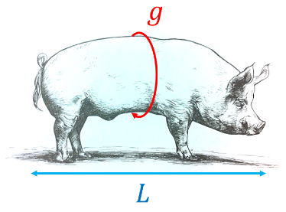
- The weight of a pig can be estimated by measuring the girth $g$ all the way around the pig and the length $l$ from tail to head in centimetres. The weight, in kilograms, is:
$$w=\frac{Lg^{2}}{13781}$$
  - A pig has a girth of 173 cm and length of 168 cm.
Estimate its weight, answer to 2 d.p.

364.86 kg
  - Estimate the length of a pig that has a weight of 400 kg and a girth of 180 cm.
Answer to 2 d.p.

170.14 cm
  - Estimate the girth of a pig that has a weight of 320 kg and a length of 150 cm.
Answer to 2 d.p.

171.46 cm
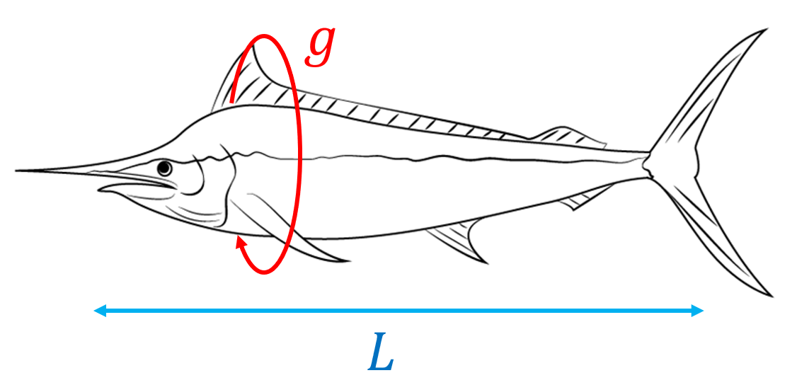
- In the United States, the weight of a fish is estimated by measuring the girth $g$ (all around the fish) at the thickest point in inches and the length $L$ also in inches. The formula for the estimated weight, in pounds, is
$$w=\frac{Lg^{2}}{800}$$
  - A blue marlin has a girth of 72 inches and a length of
156 inches. Could it weigh over 1000 pounds?

$w=1010.88$ pounds
yes
  - A swordfish is 120 inches in length and weighs 175 pounds. Estimate its girth to 2 d.p.

$34.16$ inches
- 2004 HSC Standard 2 Band 4
If $d=6t^{2}$, what are two possible values of $t$ when $d=2400$?

$$t=±20$$
- HSC Standard 2 Sample Question Band 4
The volume of a sphere is given by $V=\frac{4}{3}πr^{3}$ where $r$ is the radius of the sphere.
If the volume is 220 cm³, find the radius, to 1 decimal place.

$r≈3.7$ cm

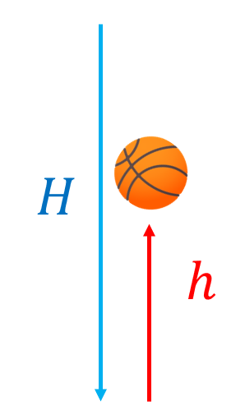
- The coefficient of restitution $c$ measures how bouncy something is by comparing the height dropped $H$ to the height bounced back $h$ using the formula
$$c=\sqrt{\frac{h}{H}}$$
The regulations say that a basketball should have a $c$ between 0.76 and 0.8.
  - A basketball is dropped from a height of 100 cm and it bounces
back up to 61 cm. Does this basketball fit the rules?

$c=0.781$, yes
  - A tennis ball has a coefficient of restitution of $0.82$. If it is dropped from a height of 10 metres, how high would it bounce back up, to 2 d.p.?

$h=6.72$ m
  - A table tennis ball has a coefficient of restitution of $0.923$. If it is dropped from a height of 10 metres, how high would it bounce back up, to 2 d.p.?

$h=8.52$ m
  - A cricket ball has a coefficient of restitution of $0.42$. If it bounces back up to a height of 10 metres, how high was it dropped from, to 2 d.p.?

$H=56.69$ m

